EasySave version 3.0 : User Manual
**GUI Version : Windows**

Application Overview
EasySave is a graphical backup application that allows users to create and execute backup jobs.
The software supports both full and differential backups.
The application is multilingual and available in French and English.

Program Launch
Double-click EasySave.exe to launch the application. The graphical interface opens automatically.
On first launch, the application will ask you to select your preferred language before displaying the main window.

Main Window
The main window is divided into two areas:
- Left sidebar : navigation menu to access each feature
- Main area : displays the active view depending on the selected option
The sidebar contains the following options:
- Create → opens the backup job creation form
- Delete → opens the backup job deletion view
- Edit → opens the backup job editing view
- List → displays all configured backup jobs
- Execute → opens the backup execution view
- Settings → opens the application settings
- Exit → closes the application
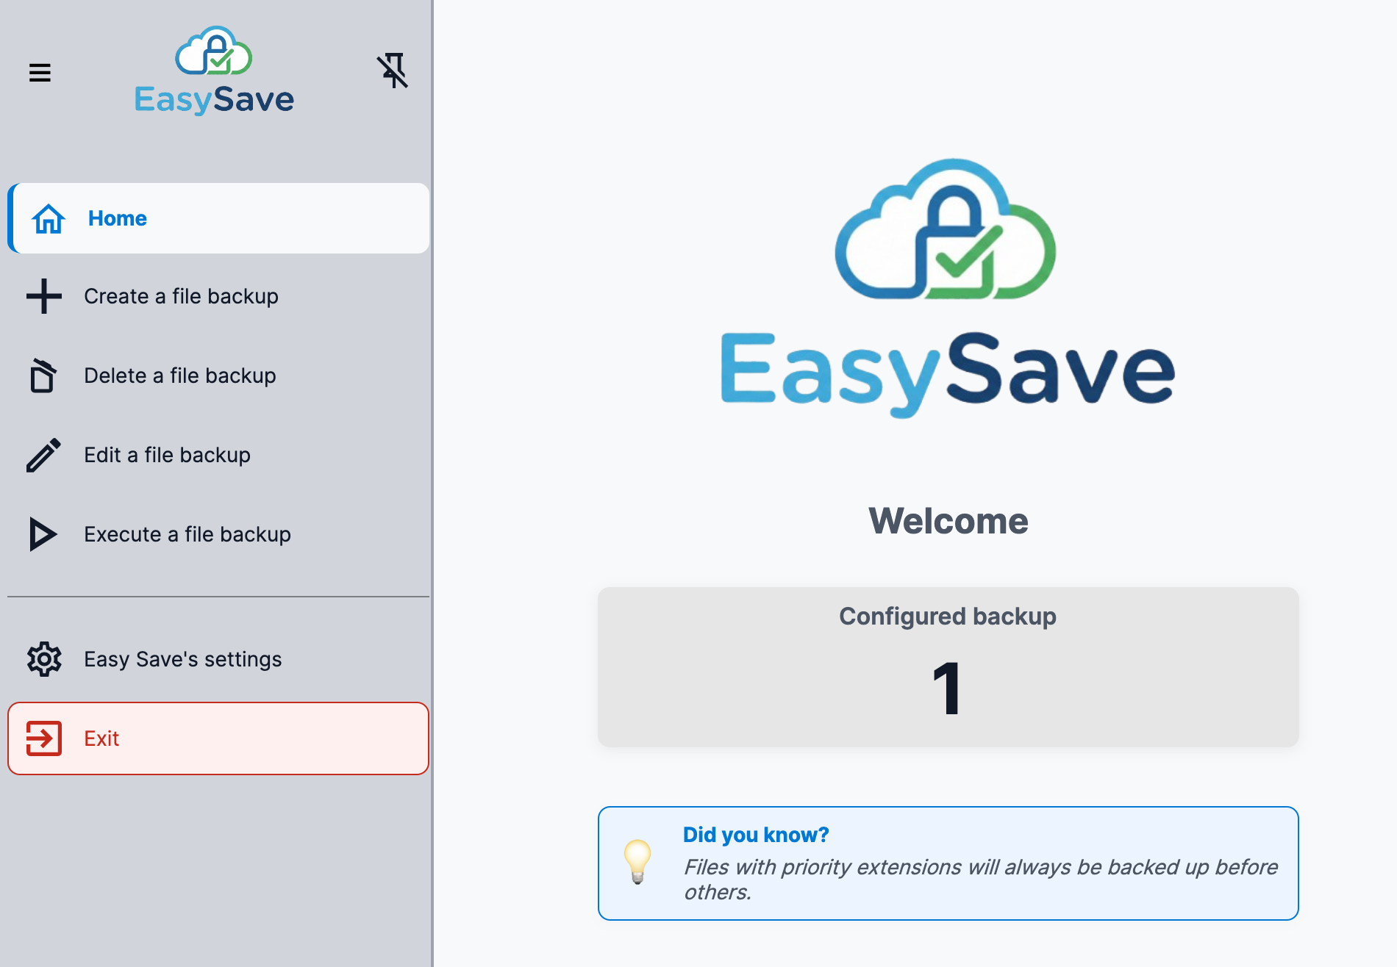

Managing Backup Jobs
Create : fill in a name, source folder, target folder, and type (Full or Differential), then click Confirm.
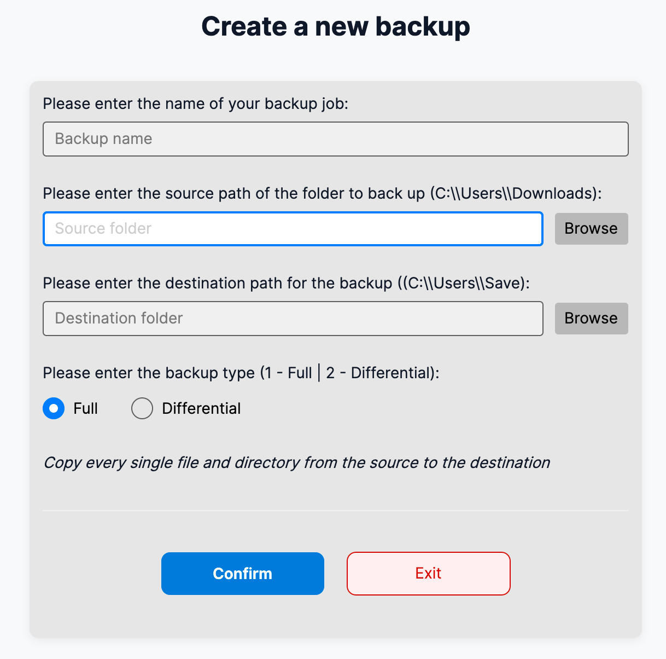
Delete : select a job and click Confirm.
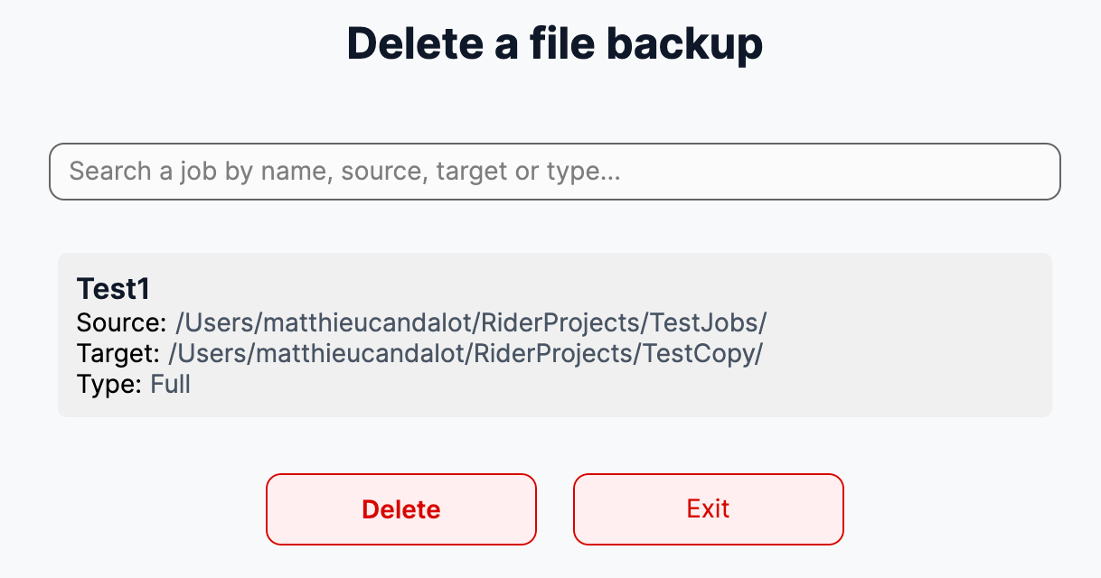
Edit : select a job, update the desired fields (leave blank to keep current value), then click Confirm.
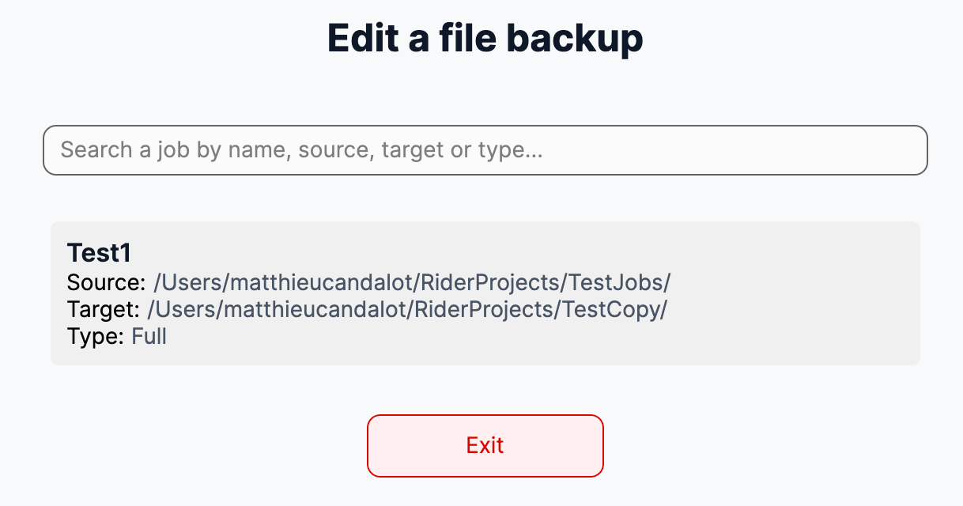
Full backup: copies all files from source to target.
Differential backup: copies only new or modified files.

Executing a Backup Job
- Click Execute in the sidebar
- Select one or more jobs from the list
- Click Execute to start
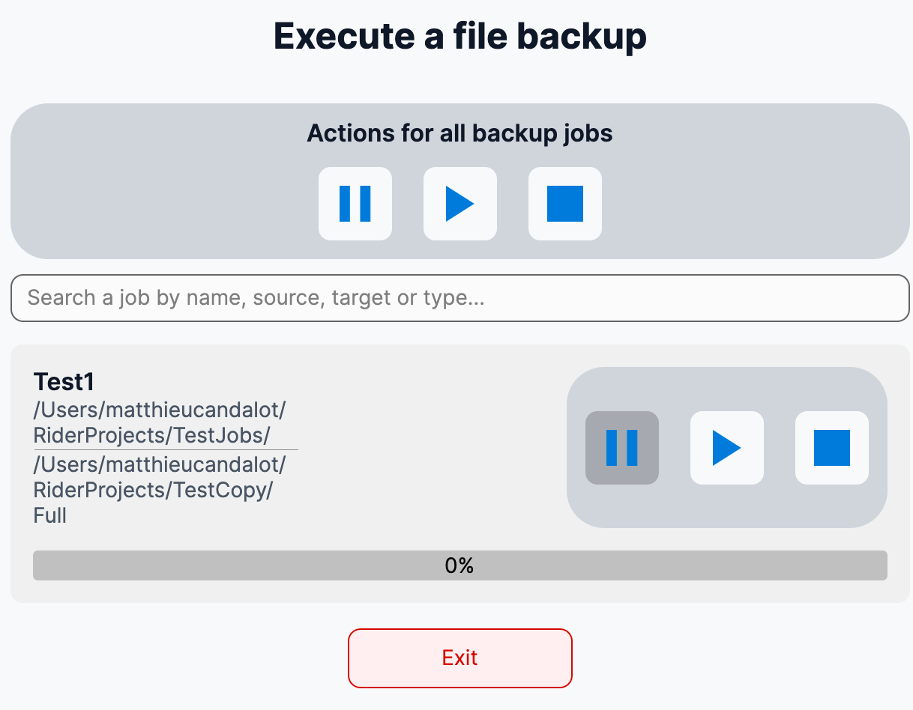
Real-Time Interaction
- ▶ Play : Starts or resume a paused job
- ⏸ Pause : Pauses the job, she becomes effective after the current file transfer finishes
- ⏹ Stop : Immediately stops the job,the current file transfer is aborted
Note: If the configured business software is currently running, the backup will not start and an error message will be displayed. Close the business software before retrying.
If backup are in progress :
- All running backup jobs are automatically paused
- No new job can start
- Jobs automatically resume once the business software is closed

File Encryption
EasySave can automatically encrypt files after copying them to the target directory using CryptoSoft.
Encryption is configured in Settings:
- Encrypted file extensions : list of file extensions to encrypt (e.g. .txt, .docx, .pdf)
- Only files whose extension matches this list will be encrypted after being copied
Only one instance of CryptoSoft.exe can run at a time on the same computer. If multiple files require encryption:
- Encryption requests are queued
- Files are encrypted sequentially
Note: CryptoSoft.exe must be present in the same folder as EasySave.exe for encryption to work.

Settings
Click Settings in the sidebar to access the following options:
Language
- French : switches the interface to French
- English : switches the interface to English
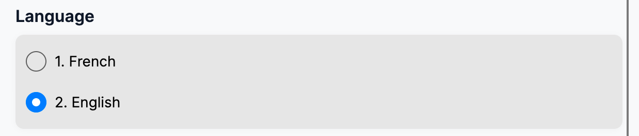
Log format
- JSON : daily log files are written in JSON format
- XML : daily log files are written in XML format
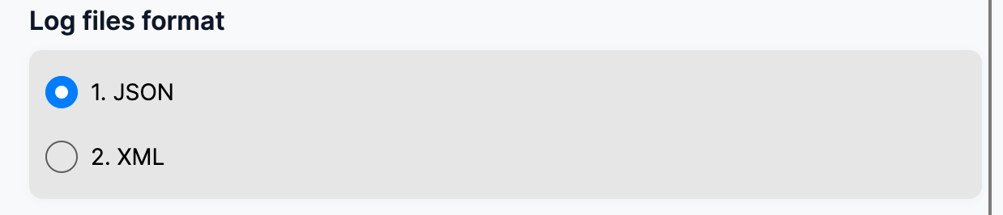

Change Log Destination
Logs storage options :
- Logs stored only locally
- Logs stored only on the Docker centralized server
- Logs stored both locally and centrally
Note: Only one unique daily log file is created on the central server
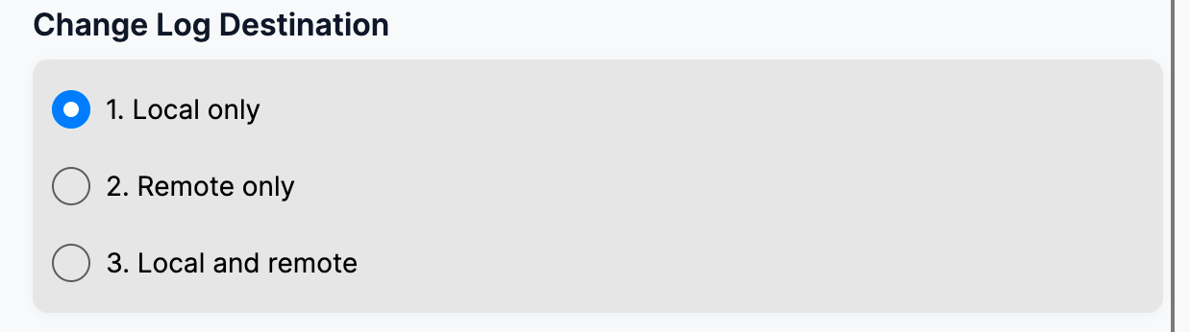
Business software
- Enter the process name of the business software to monitor
Priority File Management
- Enter the file extension name in the Settings menu.
Encrypted file extensions
- Enter the list of file extensions that should be encrypted
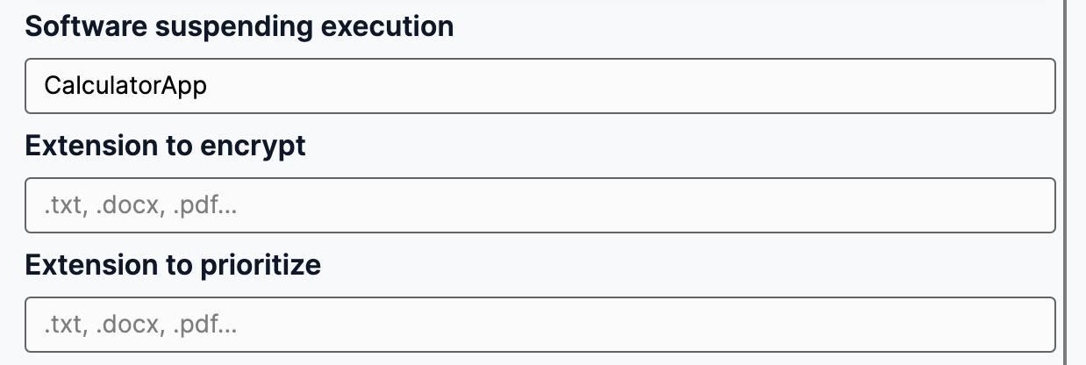
File Parrallel Transfert Restriction
- Maximum size n KB to restrict parallel large transfers
